Project Document Format for non-CPAP Countries or Projects outside a CPAP
United Nations Development Programme
Country: Cyprus
Project Title: Action for Cooperation and Trust - Crossroads for Civic Engagement phase (ACT-CCE)
CP Outcome: Cypriot inter-communal civil society sector positioned as a role model for engendering positive outcomes during socio-political transitions in Cyprus and its neighbourhood.
Output (s):
1. Civic and political leaders engaged in a genuine track 2 process in Cyprus.
2. Cypriot experiences in civic engagement leveraged to support and sustain inter-regional partnerships for social cohesion.
3. Innovation and knowledge exchange applied to evidence-based policy making in the European Neighborhood
Executing Entity: UNDP
Implementing Agencies: UNDP and respective NGOs
Brief Description
Action for Cooperation and Trust - Crossroads for Civic Engagement phase (ACT-CCE) seeks to help a Cypriot inter-communal civil society sector to emerge as a recognized partner to the Cyprus peace talks and the work of civil society organizations in the wider European Neighbourhood region. It mixes the continuity of previous phases of ACT with the adoption of programming principles which seek to improve the impact of UNDP’s peacebuilding work in Cyprus. Using knowledge exchange and practical collaboration as tools in this endeavour, the programme emphasizes the use of multi-sectoral partnerships as vehicles to strengthen the role of Cypriot civil society in the overall process to reach a settlement to the Cyprus conflict. The programme will work to support civic engagement partnerships which connect Cypriot civic leaders and thought leaders to civil society leaders in Cyprus’ near abroad. Partnerships between Cypriot and non-Cypriot organizations will aim to deepen the capacities of Cyprus’ own civil society sector, and as a result of experiential learning, great focus will be placed on Cypriot CSOs becoming more effective in asserting their influence on the Cyprus peacemaking process. At the same time inter-regional projects and knowledge exchanges will help build the capacities and expertise of civil society actors in selected countries of the European neighbourhood through the mode of horizontal collaboration. The CCE programme marks the transition from the tradition of donor funded grants to Cypriot NGOs to a self-sustaining mechanism for civil society engagement in peace and development in Cyprus and the wider region in which Cyprus is located. Therefore the programme will operate at three different but mutually reinforcing levels:
- Cypriot organizations working together to support a broad-based peace process for the island
- Cypriot organizations leveraging their own experience and expertise to support the peace building and wider good governance objectives of organizations in the European Neighbourhood area with particular emphasis on those countries covered under the European Neighbourhood Policy Instrument (ENPI).
- Non-Cypriot organizations and other donors implement initiatives, in collaboration with the CCE programme, as a vehicle for delivering development cooperation in the MENA and/or Europe/Eurasia regions by taking advantage of Cyprus’ geopolitical position and the signature service lines available through the programme.

Programme Period: 2013-2015
Key Result Area (Strategic Plan) ______________

Atlas Award ID: ______________

Start date: 1 October 2013
End Date 30 September 2015
PAC Meeting Date
Management Arrangements Direct Execution

Total resources required: 4,000,000 USD
Total allocated resources:
- Regular 0
- Other:
  - USAID (Received Funds) 1,500,000 USD
  - USAID (New Funds)
2,500,000

Agreed by (UNDP)

Situation Analysis

A. Background

Shortly after the closure of the UNDP country office in Cyprus (1997), the organisation established a project presence, initially through UNOPS, to support widespread reconciliation efforts primarily through civic engagement programming. With the financial support of USAID, UNDP has provided approximately $130 million over 15 years of work which has seen the transformation Cypriot civil society. Since 1998 Greek Cypriot and Turkish Cypriot CSOs have graduated from being the managers of discrete interactions between like-minded proponents of peace activities between the divided communities of Cyprus, to become proactive advocates of island-wide reconciliation. By 2013, a relatively mature debate on the role of civil society had become rooted in the mainstream media on the island; something which 10 years previously would have been thought improbable. This debate includes serious proposals on how to re-design the Cyprus peace process to make it more inclusive and as a result improve the quality of the role of civic engagement in the peacemaking endeavour. One result of UNDP’s concerted programming in Cyprus has been to develop a variety of civic engagement models which address the gap between broad civil society and political elites in the process of managing complex socio-political transitions. Recognition by Cypriot decision-makers of the value of civil society and civic leaders in peacemaking has helped expand the public discourse on how to resolve the Cyprus conflict. Leading decision-makers in both communities and the UN understand that such a civic engagement mechanism can help support the negotiating process which will better enable the Leaders to reach an agreement that is likely to receive broad public support.

An active and energetic civil society in Cyprus has empowered Cypriots to play an engaged role in peace-making. The emergence of an inter-communal civil society identity has given a space for Greek Cypriots and Turkish Cypriots to think of themselves not just in relation to each other, but also their place in the wider world. The island’s current financial crisis has made many realise that Cyprus is not immune from the forces of globalisation, and resolving Cypriot problems cannot be achieved in isolation from events on the international stage. The connection between the domestic and global has made many Cypriots re-examine their own attitudes to global citizenship and what it means in the world today. The island’s proximity to societies burdened with violent conflict and the consequences of socio-political upheaval has forced many Cypriots to question the tenability of the island’s division. The Government of Cyprus readily accepts that it is part of a complex region, and it needs to play a constructive role within it. Cypriots who have taken a central role in building Cyprus’ civil society structures recognize that Cypriot experiences in managing conflict and building peace is a transferrable asset, which could help connect the island to a global social good agenda. Cyprus can exchange experiences of civic engagement with near neighbours, to show how empowered citizenship can furnish ordinary people with more effective intellectual tools with which to build mutual trust. Partnerships of this kind would help strengthen the capacities of Cypriot organisations to continue to work on shaping the future of their society, while becoming part of a larger internationalised civic movement for social change.

This consensus has been spurred by the experiences of inter-communal reconciliation programmes. Simultaneously, UNDP’s 2013 outcome evaluation concluded that though Cypriot CSOs had made huge strides in supporting reconciliation efforts, an inter-communal civil society sector still requires time to mature, and international support for civil society should not be withdrawn just at the time when the peacemaking process in Cyprus may well be entering its most crucial stage. Many commentators believe 2014 will be a significant year in the Cyprus peace process given the socio-economic crisis faced by both communities on the island. Thus, a key part of the programme strategy, endorsed by the outcome evaluation, is to use the accumulated civic engagement experience to connect Cypriot CSOs and thought leaders to Cyprus’ near abroad, as a means to deepen the capacities of the island’s civil society sector in order to support the overall peacemaking process on the island.

B. Needs Analysis: Civic engagement in the global, regional and local context

The global situation demands that development cooperation practices and policy be dramatically redesigned to meet the growing demands of a world facing ever increasing levels of socio-economic and political stress. Since 2009 the world has witnessed tremendous changes which while leading to a series of global crises and the collapse of financial institutions and governments, heighten the demand for development solutions rooted in economic and political inclusion. Events in the Arab States and beyond are reminders both of the power of civic participation and the need for continued support to governments and societies to sustain democratic transition. Concerns about the legitimacy and accountability of governments are on the rise worldwide, which have catalyzed a new “accountability agenda” involving actors, both public and private, and all others in between to mobilize on the issue of accountable governance, gender-responsive institutions and the need for a new compact between state and society. In substantive terms the post-2015 development framework must take into account how the context for development has changed. It will need to consider climate change and environmental vulnerability, recent crises and volatility arising from economic globalisation, the changing nature of global governance, patterns of inequalities between and within countries, as well as trends relating to technology, demography, urbanisation, and migration, among others.

All these issues underpin the self-evident arc of vulnerability and fragility which spans the politically defined European neighborhood region, geographically covering countries from North Africa, the Middle East and the Caucasus and into Eastern Europe. Major donors and UN system organisations have been present throughout this area for many years. However, the changing donor landscape, characterised by demands to adopt more cost-effective operational models that deliver better development impact, has become paramount. Financial stringency and the mantra to “do more with less” is forcing donors to rethink their own models for doing business. Maximizing knowledge partnerships and exchanges between developing societies and communities has been a key dimension of the move towards making better use of the variety of financial and non-financial assets available to the international development community. This paradigm is particularly relevant to the Euro-Mediterranean region in which Cyprus is located.

Donors readily acknowledge the similarities between the transformative experience of the Arab world and that of the Central and Eastern European countries that emerged from the former communist bloc some twenty years ago. While the historical, cultural and political experiences differ, the desire to change lives and join modern democracies is similar. Eastern European and the Arab countries have much in common: geographic proximity and historical and cultural ties – where the elite from Arab countries were often educated in Europe and particularly in Eastern Europe during the 1950s and 1960s. Today, these strong historical, cultural and family ties continue and, in many instances, are leading the economic, commercial and trade activities between the Arab and the East European countries.

UNDP and USAID have traditionally been major donors in both the Arab region and Eastern Europe and understand the need to utilise inter-regional collaboration to enhance the quality of programme delivery. Both organizations have taken steps to make use of their respective inter-regional knowledge sharing potential while specific knowledge exchanges have taken place between country programmes. The challenge ahead is how to better opertionalise this approach within the existing legal and operational frameworks and under the current political realities to create secure venues to enable the systemization of these inter-regional exchanges and partnerships.

Given this situation the USAID-UNDP collaboration in Cyprus provides a solid institutional base to begin to address this challenge. In particular Cyprus provides a unique entry point to addressing the paradigm in inter-regional knowledge exchange through the 15 years of civic engagement and peace building projects on the island to support Cypriot civil society’s reconciliation work. Since 1998 USAID-UNDP programmes have funded over 500 grants totaling 130 million USD ensuring the implementation of initiatives which meshed development themes such as infrastructure, health and environment with peace building initiatives and island wide reconciliation. Peace building projects have included advocating for a more diversified media landscape through community media; producing evidence-based research to shape the peace and reconciliation policy dialogue; encouraging more active citizen engagement – including by women and youth in the peace process; promoting the economic benefits of a solution; interjecting multiple perspectives and critical thinking into the educational system; and demonstrating the power of participatory processes in projects that help build confidence between the two communities. The journey, which has led Cypriot civil society to the point where it can engage meaningfully with the “high politics” of resolving the Cyprus problem, has created a wealth of knowledge, skills, and experience with policy makers and practitioners in Cyprus and the wider region, including the Middle East and North Africa (MENA), the Caucasus region and the Balkans.

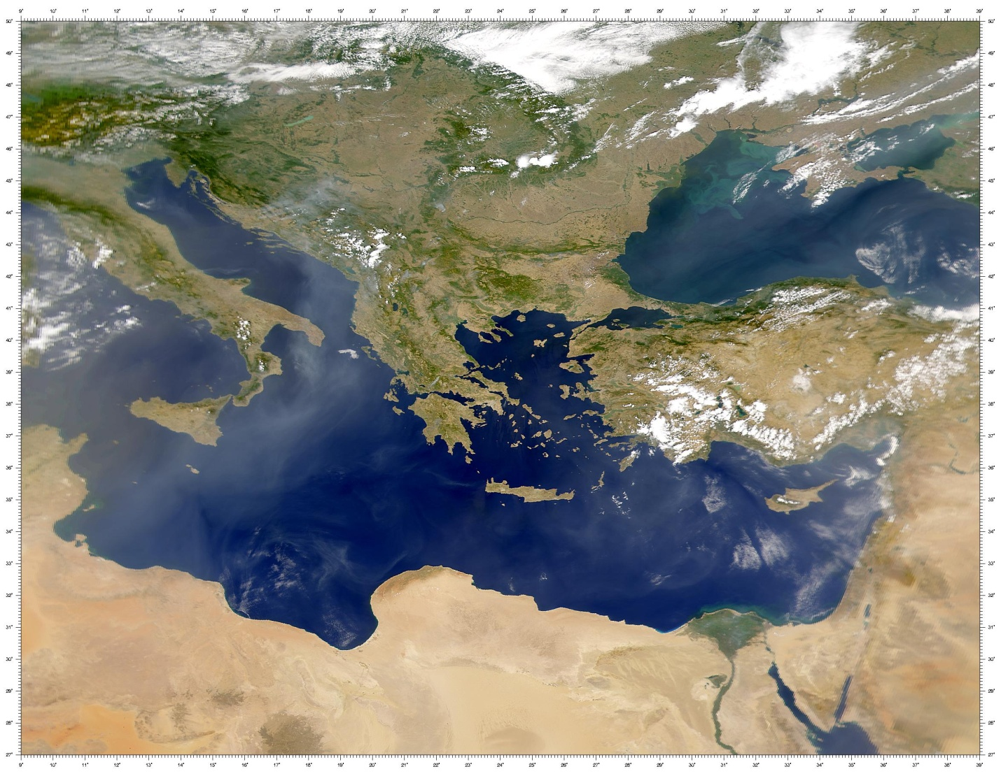
In October 2012 the premise that Cyprus could be an inter-regional venue for civil society knowledge exchange and practice was substantiated through the Power of One Inter-Regional conference. Supported by a coalition of Cypriot civil society organizations and UNDP, the conference attracted 200 delegates from 28 countries from Central and Eastern Europe, the Middle East and North Africa and Cyprus; translating into a groundbreaking knowledge exchange event on citizen-led innovation and social change practices during periods of transition. The conference created the space for fostering innovation, sharing best practices and networking, and delegates endorsed 5 concrete inter-regional projects involving partnerships which bound Cypriot, Arab and Eastern European CSOs.

Against this background the business case for the creation of the CCE programme rests on a number of geo-strategic considerations which combine support to peacemaking in Cyprus with innovative approaches which positions Cyprus as a crossroads for inter-regional collaboration:

- The island of Cyprus is situated as a historical, cultural and geographical crossroad between Eastern Europe and the Middle East/North Africa, and while politically it is part of Europe, geographically it is part of the wider Middle East.
- The Cypriot historical experience with transition and socio-political change is instructive and in this context Cyprus hosts one of the most concentrated civil society strengthening programmes which has seen a huge investment in citizen-led social change initiatives.
- Cyprus is becoming the location of choice for a number of organizations wishing to operate in the MENA region, due to its proximity and stability. In this context the programme can provide a safe operating and policy space for civil society organizations and development actors to forge partnerships and strategic actions to meet development objectives through their respective projects and programmes. The CCE programme can provide business solution to a variety of development organizations which wish to benefit from secure conditions and high quality facilities which will allow them to pool knowledge to craft innovative strategies for addressing regional and national development challenges.
- Cypriot civil society has transformed itself over the past 20 years, and today plays a constructive role to support reconciliation on the island. The CCE programme would enjoy the support of organizations across Cyprus and be an organic outcome of the peace building process on the island, serving as a concrete example of success for others in the region to emulate.
- The Cyprus problem continues to be a possible source for wider political tensions, especially given the disputes around the exploration of natural gas in the Eastern Mediterranean. Thus a settlement to the Cyprus problem remains desirable within the overall context of regional stability objectives. In this respect Cyprus’ inter-communal civil society movement continues to play a very significant role in strengthening the climate for reconciliation and provides support to the peace process on the island. At the same time Cypriot CSOs still have much to do in order to define an independent and robust inter-communal constituency to advocate for a just settlement. The CCE programme will provide opportunities for Cypriot organizations to continue to graduate by utilizing knowledge exchange projects and collaboration with organizations in the wider region. Such efforts will allow Cypriot organizations to continue to support multi-level efforts aimed at resolving the Cyprus conflict.

C. Previous UNDP programming in civic engagement

UNDP’s role in helping to address Cyprus’ conflict is unique in the global UNDP experience. In Cyprus, UNDP has been able to contribute to the peacebuilding and reconciliation process for a significant period of time and with relatively high levels of financial and human resources. UNDP has also generated a wealth of experience and capacity that has served Cyprus well. Collectively, the USAID-funded UNDP programmes (1998-2013) have directly reached more than a hundred thousand Cypriots island-wide through bi-communal initiatives that seek to strengthen inter-communal relations and trust by creating opportunities for civil society to participate in the peace process and fostering an environment conducive to reconciliation.

UNDP and USAID began providing support for small-scale civic engagement reconciliation efforts in Cyprus in the 1970s. The low-profile endorsement of bi-communal contact changed in 1998 when the two organisations agreed to establish the Bi-communal Development Programme (BDP). The BDP was the first concerted effort by the international community to solicit and fund civil society initiatives that brought Greek Cypriots and Turkish Cypriots together to work on issues of common concern. Although the organizations working on BDP activities focused on ‘neutral’ issues such health care and the environment, cross-community civil society work was unheard of and the motivations of those participating in the initiatives were regularly questioned. In spite of this the BDP had a huge impact on changing the practicalities of bi-communal work, because it was the only mechanism available for supporting structured bi-communal interaction, and by 2004 70% of BDP projects had succeeded in achieving some form of face-to-face contact (either on the island or off-island) between Greek Cypriots and Turkish Cypriots.

Table 1: Progression of ACT’s support: Stages of support to peace building and reconciliation 2005-2013

ACT I (2005-2008) | ACT II (2008-2011) | ACT III (2011-2013)
Promote contact | Deepen relations | Sustain relations through mechanisms and structures
Many projects | More strategic projects and partnerships | Supporting Partners
Initialising projects | Capacity building of key Partners | Policy change, sustainability of efforts and transfer of knowledge

Using the lessons of the BDP, UNDP-USAID collaboration was transformed in 2005, when the Action for Cooperation and Trust Programme (UNDP-ACT) was launched. UNDP-ACT established a niche within the reconciliation process in Cyprus and targeted the capacity of civil society to feed into the political process. Between 2005-2013 UNDP-ACT passed through three distinct phases of evolution which responded to the growth of civic engagement priorities on the island. The first two phases of ACT (Phase I 2005-2008 and Phase II 2008-2011) refined the approach to citizen peace building in Cyprus, moving gradually from many small projects, aimed at showing that inter-communal cooperation was possible, to a few large thematic initiatives which sought to leverage profound changes in societal thinking on the Cyprus conflict. Following critical evaluations, ACT retained what worked over the years and sought to focus its programme in a manner which maximized impact. The second phase of ACT in 2008 coincided with the start of a new Cypriot peace process under UN auspices. This had a profound impact on the formulation of ACT Phase II, and prompted the programme to define itself in terms of helping to prepare civil society to engage in the peace process and post-settlement phase; in other words to help create spaces where citizens could engage fully with the political process for negotiating a settlement and to influence that process through different formal and informal mechanisms. It was at this point that civic engagement became the guiding principle for UNDP’s support.

D. Justification for extending Action for Cooperation and Trust

The Action for Cooperation and Trust: Crossroads for Civic Engagement phase (ACT-CCE) seeks to help a Cypriot inter-communal civil society sector to emerge as a recognized partner to the Cyprus peace talks and the work of civil society organizations in the wider European Neighbourhood region. It builds on the lessons of the third phase of ACT to create new innovative mechanisms for civic engagement where Cypriot thought leaders and civil society leaders could pool their collective experiences to support transition in Cyprus and exchange that knowledge with peers in neighbouring countries. ACT-CCE also responds to the findings of the 2013 outcome evaluation which recommended the extension of the ACT programme since an inter-communal civil society sector still requires time to mature on the island.

During ACT III (2011-2013) specific efforts were made to elevate the role of civil society to the policy level in order to affect the design and direction of the Cyprus peace process. The theory of change at the time focussed on civil society efforts to engage with both more people outside of their circle of the “inspired few” and with key decision makers. In practical terms this translated into a focus on building and consolidating capacities to influence policy making on the island in relation to reconciliation between the two communities. A significant outcome of ACT III was the creation of spaces for the key people from political parties, the business community and key civic associations such as trade unions, to design a credible Track II process, which could act as a support mechanism for the two Leaders and the participle negotiators. Political elites in both communities embraced this form of support and encouraged UNDP’s assistance. Civil society organisations also developed new modes of partnership with NGOs in Arab and Eastern European countries, which demonstrated the value of social mobilization at an inter-regional level, where the experiential exchange of best practices helped to build the capacity of Cypriot and non-Cypriot organisations alike.

The ACT-CCE phase now responds to the demand by influential groups in society to support a more inclusive peace process and the evolution of inter-regional CSO partnerships. Cypriot CSOs have helped create a sophisticated online knowledge exchange portal which will become a gateway for Cypriot CSO expertise in civic engagement. This “Mahallae” platform (meaning Neighbourhood in Arabic, Greek, Turkish and several other languages) offers civil society activists from Cyprus, the Arab region and Europe a virtual conferencing space to exchange ideas and build inter-regional partnerships to support their work in social cohesion and reconciliation. Mahallae hosts a number of interactive learning tools developed by Cypriot CSOs during ACT III, enabling people to interact, innovate and design joint projects. Second, the Mahallae platform is now the portal for the Social Cohesion and Reconciliation Index (SCORE). The SCORE is a revolutionary way to measure and analyse progress towards reconciliation, which identifies the most important indicators of social cohesion which need to be addressed in order to extend the scope and efficacy of reconciliation. The tool is a major contribution by Cypriot civil society to practical peace-building, and its results can provide evidence-based policy options for decision-makers and practitioners concerned with advancing a Cyprus settlement, while the potential for replication in other conflict countries is being explored.

Strategy

D. Programme Objectives and theory of change

Civic engagement is generally defined in terms of people’s participation in the decisions which impact their lives and consists of the methods and approaches that people and organized networks of people (CSOs) influence and share control over priority setting, policy making, resource allocations and access to public goods and services. In it broadest conception this means the engagement of societal actors and stakeholders at different levels. It’s within this overall understanding that Cypriot civil society has demanded a greater degree of inclusivity in the peacemaking process on the island. This has been supported by consecutive reports of the UN Secretary-General, in which appeals have been made to the Cypriot leadership to create a greater space for civil society involvement in the peace process.

In this context, the ACT-CCE programme seeks to help a Cypriot inter-communal civil society sector to emerge as a recognized partner to the Cyprus peace talks and the work of civil society organizations in the wider European Neighbourhood region. Using knowledge exchange and practical collaboration as principle tools in this endeavour, the programme emphasizes the use of multi-sectoral partnerships as vehicles to strengthen the role of Cypriot civil society in the overall process to reach a settlement to the Cyprus conflict. The programme will work to support civic engagement partnerships which connect Cypriot civic leaders and thought leaders to civil society leaders in Cyprus’ near abroad. Partnerships between Cypriot and non-Cypriot organizations will aim to deepen the capacities of Cyprus’ own civil society sector, and as a result of experiential learning, great focus will be placed on Cypriot CSOs becoming more effective in asserting their influence on the Cyprus peacemaking process. At the same time inter-regional projects and knowledge exchanges will help build the capacities and expertise of civil society actors in selected countries of the European neighbourhood through the mode of horizontal collaboration.

Using its Cyprus-based position as a crossroads between Europe and the Middle East and North Africa (MENA) the programme will create inter-regional partnerships which focus on innovation in citizen-led efforts to support socio-political change in Cyprus and its neighbourhood. The mechanism for this effort will rest with the practice of knowledge exchange, wherein Cypriot civil society can share experiences with peers in the neighbourhood, while also benefiting from exposure to and involvement in inter-regional partnerships. In this regard the programme is defined by the multiple partnership networks which its work will forge. Therefore the programme will operate at three different but mutually reinforcing levels:

- Cypriot organizations working together to support a broad-based peace process for the island
- Cypriot organizations leveraging their own experience and expertise to support the peace building and wider good governance objectives of organizations in the European Neighbourhood area with particular emphasis on those countries covered under the European Neighbourhood Policy Instrument (ENPI).
- Non-Cypriot organizations and other donors implement initiatives, in collaboration with the CCE programme, as a vehicle for delivering development cooperation in the MENA and/or Europe/Eurasia regions by taking advantage of Cyprus’ geopolitical position and the signature service lines available through the programme.
Table 2: Summary of Programme Components
Objective | Beneficiaries and Partners | Intended Results
Civic and political leaders engaged in a genuine track 2 processes in Cyprus | - The Leaders of the two communities  - An inter-communal Cypriot civil society sector  - Political party representatives, business leaders and other influential civic leaders. | A meaningful and sustained Track II process, which incorporates representatives of the wider Cypriot society, ensuring that the voices and concerns of ordinary Cypriots are heard by the peace negotiators and incorporated in the decisions regarding a settlement.
Cypriot experiences in civic engagement leveraged to support and sustain inter-regional partnerships for social cohesion. | - Civil society organizations and thought leaders from Cyprus and the European neighbourhood. | Establishment of an inter-regional community of practice, where CSOs working towards social cohesion can benefit from the experience and solidarity drawn from a network of like-minded organizations.
Innovation and knowledge exchange applied to evidence-based policy making in the European Neighborhood | - International donors, development policy makers and practitioners | Cyprus emerges as a venue for innovation in the development of civic engagement development solutions which can serve the European Neighbourhood area, and allowing conditions where organizations can pool resources and knowledge to address regional challenges.

In this context the ACT-CCE programme will aim to provide high-quality affordable solutions to public, private and civil society organizations mandated to improve processes of civic engagement and social cohesion in the region. It will provide a range of services that brings together development organizations and CSOs to exchange knowledge and provide innovative solutions to inter-regional (Arab-Europe) social problems. This will be achieved through knowledge based services, management development expertise and inter-disciplinary social networks which facilitate inter-regional collaboration and partnerships encompassing civil society entities, public bodies and private sector organizations.

Theory of change in Cyprus

The programme will be guided by a theory of change which targets the social drivers underlying citizens’ propensity for moving towards or away from reconciliation. It builds on the axiom that in Cyprus there is a strong correlation between levels of civic engagement and capacities to develop constructive models for social cohesion and reconciliation. The Social Cohesion and Reconciliation Index (SCORE) was developed in Cyprus to identify the drivers of the political conflict between the island’s communities and understand the points where targeted peace and development actions could make a difference. SCORE is a statistical modelling tool which allows governments, donors and development practitioners to be able to identify the intrinsic trends which either strengthen or undermine social cohesion, combined with a capacity to measure a society’s propensity to move towards reconciliation. By applying statistical techniques such as structural equation modelling and fuzzy cognitive mapping, the tool can help decision-makers to navigate policy through periods of socio-political and economic transition, having both a predictive and prescriptive capacity, which is grounded in a robust evidence-based social science methodology.

Social Cohesion refers to the quality of coexistence between the multiple groups that operate within a society. Groups can be distinguished in terms of ethnic and socio-cultural origin, religious and political beliefs, social class or economic sector or on the basis of interpersonal characteristics such as gender and age. Quality of coexistence between the groups can be evaluated along the dimensions of mutual respect and trust, shared values and social participation, life satisfaction and happiness as well as structural equity and social justice. Reconciliation refers to an on-going effort for re-establishing relationships between groups that were previously engaged in a serious conflict. This effort can be at the structural, societal and individual level, as well as attitudinal and behavioural.

The SCORE model in Cyprus has demonstrated that a symbiotic relationship exists between social cohesion and reconciliation and that this relationship governs the quality of co-existence between the different ethnic and socio-political groups. Positively transforming social cohesion factors, such as social distancing, anxieties and stereotypes accelerates the capacity of reconciliation processes to reverse the damage caused by the legacy of conflict and socio-political division. At the same time the process of reconciliation has the effect of restoring the quality of coexistence between conflictive groups. In 2013 the SCORE data identified the most important social cohesion variables in the context of the Cyprus conflict, which need to be addressed in order to strengthen the impact of reconciliation. The key feature which underpins this analysis is the quality of civic engagement, while the SCORE has the ability to identify the types of civic engagement activities and broader policies that can have the most effective impact on trends towards reconciliation and social peace. Therefore the overall programme will seek to apply targeted projects which positively transform the drivers for social cohesion, while simultaneously strengthening the capacity of civic engagement to support reconciliation.

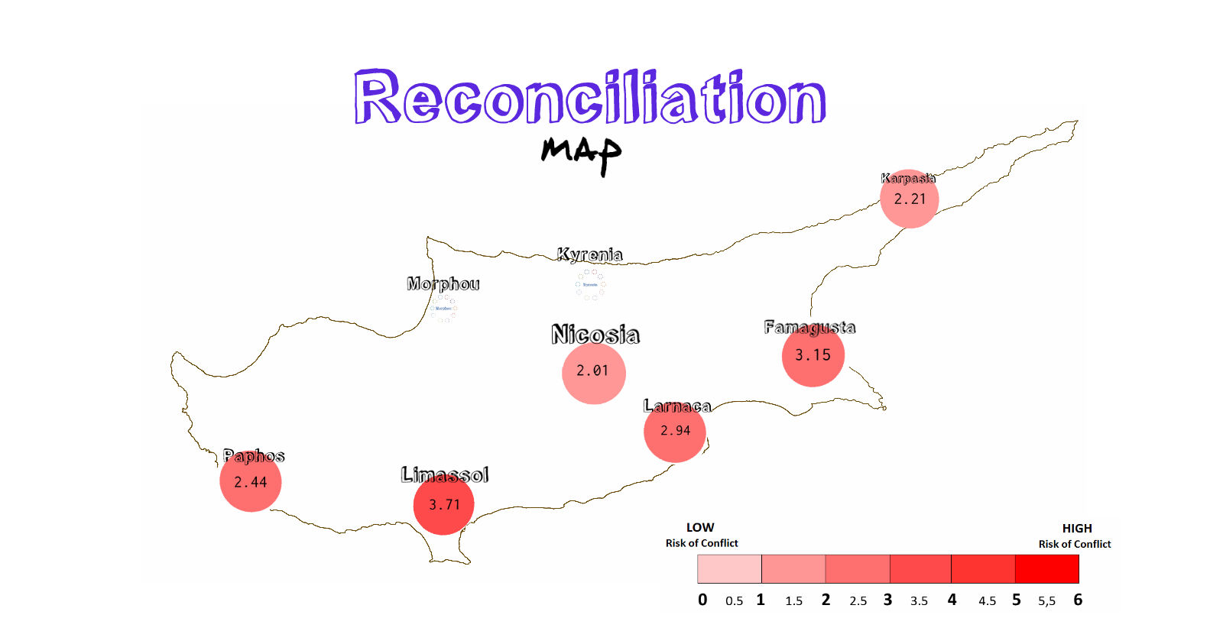

The reconciliation map produced by the SCORE dataset demonstrates the propensity, by region, of openness among citizens to reconciliation. A high index number reflects a high degree of resistance to reconciliation, which in general terms represents the low likelihood to support a settlement plan in a referendum to resolve the Cyprus conflict. The composite index has been calculated on the basis of specific social drivers which govern the political opinion of the local community. Therefore citizens in Nicosia which exhibit a low index (2.01) are far more open to and active in reconciliation. On the other hand the index of Limassol (3.71) is far higher and demonstrates lower readiness for reconciliation.
Nicosia
Limassol

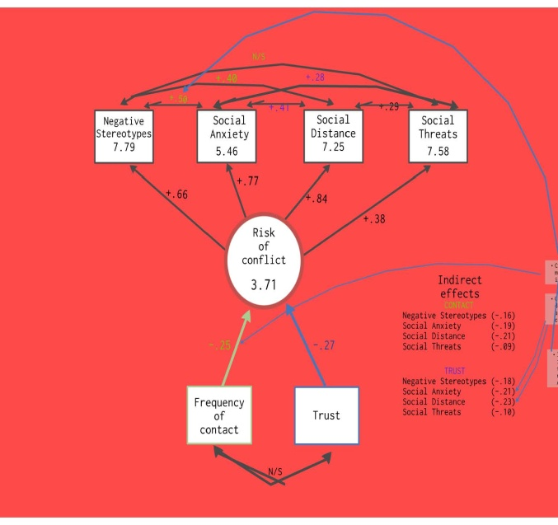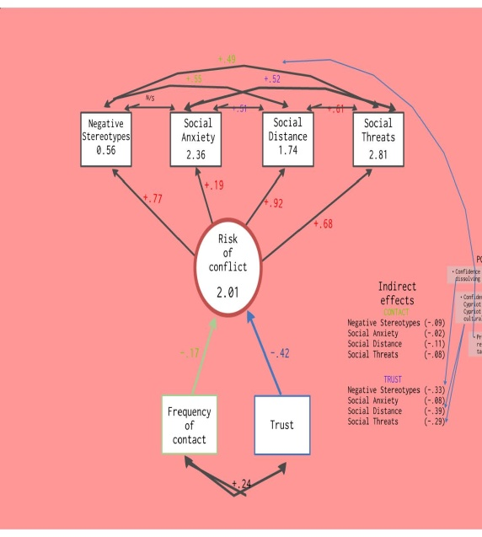

The graphics above demonstrate the utility of the SCORE to guide the programme’s theory of change. The example compares the social drivers between Nicosia and Limassol and demonstrates the extent of the high level of resistance to reconciliation in Limassol. This example shows how a theory of change would focus on positively influencing the 4 main social drivers: negative stereotypes, social anxiety, social distance and social threats. As illustrated by the example of Nicosia, reducing the negative value of these drivers will help provide a better environment for reconciliation between the two communities. The example shows that one of the major influencers for increasing the value of reconciliation in Nicosia is high levels of civic engagement and positively structured contact between Greek Cypriots and Turkish Cypriots. It is clear that this has come about due to a number of factors, including proximity of Greek Cypriots and Turkish Cypriots but also due to years of managed and positively structured peace building and civil society projects in the city. In Limassol all the negative social drivers which undermine reconciliation and increase alienation are very high, while there is no linkage between frequency of inter-communal contact and trust. This example taken from the two largest population centres on the island, illustrates the value of investing in civic engagement efforts which support meaningful contact as a vehicle towards reconciliation and building confidence. At the same time the SCORE Index provides a sophisticated analytical tool which can guide policy and programme design. Regardless of the outcome of the political process on the island, the importance of trust between the two communities will remain crucial. In the case of political reunification (probably a federal solution), a velvet divorce (agreed and legally recognised separation) or the continuation of the status quo (something which will be a burden for both communities), Greek Cypriots and Turkish Cypriots will need to share the island and its finite resources.
Though developed in Cyprus, experts in the field have already identified the potential for the SCORE methodology to be applied in multiple country contexts. USAID has already requested a partnership with UNDP Cyprus to replicate the score in Bosnia. Similarly, interest in the SCORE has been expressed by organisations in Israel, Kenya and Sri Lanka. In addition to using the SCORE as a policy tool in Cyprus, the CCE programme will explore options for replicating the SCORE in other countries in the European and MENA regions, through partnerships with UNDP offices, donors and research institutions.

E. Programme Components

OUTCOME

- Cypriot inter-communal civil society sector positioned as a role model for engendering positive outcomes during socio-political transitions in Cyprus and its neighbourhood.

Two main findings emerged from the 2013 outcome evaluation of the ACT programme. First, it was clear that support is still required to promote the formation of a strong and vibrant inter-communal Cypriot civil society sector, which could make a major impact on the Cyprus peace process and the larger dimension of social-political reconciliation. In particular the evaluation recommended the funding of activities which supported capacities of this sector which would help it graduate in the area of advocacy. Second, the evaluation recognized that Cypriot civil society had been transformed over the last 10 years and it had accumulated an incredible corpus of knowledge and practice, and this high quality output should be shared outside Cyprus as a vehicle to leverage wider partnerships. These two findings underpin the design of the programme outcome for ACT-Crossroads for Civic Engagement.

OUTPUTS

- Civic and political leaders engaged in a genuine track two processes in Cyprus

Under this output the programme will aim to strengthen the Cyprus’ legal framework for civil society and civic engagement activities and help consolidate a recognizable civic leaders dimension to the peace negotiations.

Modernizing NGO legislation in the Republic of Cyprus has been pending for several years. The current legislation is outdated, fragmented and does not recognise the status of public benefit organisations. In 2008-2009 UNDP supported the efforts of civil society legal reformers by funding the mission of the European Centre for non-for-profit law (ECNL) and the drafting of new legislation. Since then progress to get the new legislation adopted has stalled. In 2013 the President of the Republic of Cyprus, Nicos Anastasiades, made a commitment to conclude the process to adopt new legislation. However, civil society leaders have concerns the current draft legislation does not meet European standards and still fails to codify the basic norms for public benefit status. The adoption of strong and enabling civil society legislation will create a solid framework for civic engagement in all walks of life in Cyprus, including work aimed at supporting inter-communal reconciliation.

Responding to the narrow nature of the Cyprus peace negotiations which has traditionally limited civic engagement in Cypriot peacemaking, UNDP-ACT designed the Participatory Peacemaking Initiative (Approved by LPAC 21 December 2012). Launched in January 2013 the project focussed on introducing the experiences of participatory peace-making models from N. Ireland, South Africa and the Balkans to Cypriot political and civic leaders, and using this as a stimulus for discussions on how the Cypriot peace process could become more inclusive. During June 2013 senior peace negotiators from South Africa and N. Ireland led symposiums with representatives of all of Cyprus’ political parties, civic leaders and business leaders from the two communities. The outcome was that all the participants acknowledged that successful peace processes in the world have one thing in common: they were designed with public participation in mind, whereas the most intractable conflicts have often suffered from a democratic deficit. This affirmation of a strong civil society role is supported by UN Security Council Resolution 2114 (30 July 2013), which states: “Agreeing that active participation of civil society groups, including women’s groups, is essential to the political process and can contribute to making any future settlement sustainable...”. In addition both Leaders have endorsed the project, while the UN Good Offices has embraced it as a direct vehicle for ensuring wider public participation. In September 2013 50 Greek Cypriot and Turkish Cypriot political, civic and business leaders will meet in Malta to discuss the design of a genuine track 2 process for the Cyprus peace talks. The forum will be facilitated by high level political figures from the United Kingdom, Ireland, South Africa and Bosnia. The objective will be to create a process which can be endorsed by the two Leaders. Any initiative which emerges from the high level Malta workshop will fall under the ACT-CCE extension.

- Cypriot experiences in civic engagement leveraged to support and sustain inter-regional partnerships for social cohesion.

ACT-Crossroads for Civic Engagement will provide a funding window for inter-regional partnership projects. This builds upon the success of five partnership projects funded by UNDP-ACT in 2013. These projects emerged from the 2012 Power of One Conference receive co-funding from the USAID Office for Middle East programmes. The five inter-regional projects are listed below:

Table 3: Inter-regional projects funded through Power of One Conference

Name of inter-regional project | Partnering Countries | Objective
Media Buffer Zone Project | Cyprus, Egypt, Bosnia & Herzegovina | Support to CSOs to produce and disseminate professional media messages
Ambassadors for Cross-cultural Dialogue | Cyprus, Morocco, Romania, Serbia | Reduce prejudice and xenophobia among youth
i-100 | Cyprus, Egypt | promote volunteerism as a lifestyle
Interregional Networking for Citizen Participation | Cyprus, Jordan, Bulgaria, Slovakia, Tunisia | Transfer experiences of citizen participation
Integrating anthropology perspectives into Peacebuilding | Cyprus, Iraq, Hungary | Review of comparative anthropological approaches used in peacebuilding.
In the autumn of 2013 the CCE programme will scale up the following two projects to a maximum value of 150,000 USD each. This will include an amendment to the current contracts currently signed with the respective Cypriot partners.

Project Name | Name of Cypriot Partner
Media Buffer Zone Project | Cyprus Community Media Centre
Ambassadors for Cross-cultural Dialogue | Youth Power

In addition ACT-CCE will create a funding window for a set of youth leaders support projects, which will be solicited, assessed and funded through a competitive call for project proposals. The objective of funded projects will be to share lessons learned from across the Mediterranean region to develop the skills and knowledge of young civil society leaders. An emphasis will be placed on Cypriot organisations able to work in partnership with organisations in Arab Mediterranean countries and other European countries to play a meaningful and constructive role in transforming the social, political and economic situation of young people through a dialogic and cooperative partnership with government and other influential actors in society such as business corporations. Through funded projects the space will be created for an inter-regional exchange of lessons between the European and Arab regions on youth leadership projects and programmes. In particular the Project will focus attention on sharing and analysing Cypriot and other European experiences in youth leadership. It will remain cognizant of lessons learned from Central and Eastern European experiences, where the management of socio-economic transitions in the past 20 years have profoundly affected the lives of youth. Knowledge linkages will be sought with current programmes such as the European Union’s Eastern Partnership Youth Window, with emphasis on youth participation, voluntary service, inter-cultural learning and preparation for the world of work. Priority areas for funding are stated below:

Table 4: Youth leaders’ priority areas
Priority | Description
Organisational capacity and constituency building | Initiatives that build the capacity of youth leaders to develop civil society organisations which can play a strong role in supporting social cohesion in their communities and address the practical needs of young people, especially young women and youth from traditionally marginalised groups. The purpose is to help develop strong civil society entities which can represent the needs of young people in times of transition and provide opportunities for young people to influence the decisions which affect their lives.
Advocacy for social and economic change | Initiatives that provide youth leaders with the knowledge and tools to create visible platforms and outlets for formulating policies which can improve the lives of young people. The purpose will be to lead to tangible results where the advocacy actions address major social and economic deficits affecting young people. The initiatives will be expected to mobilise the support of key decision-makers who have the ability to change or amend policy which can improve the lives of young people.
Constructive dialogue across conflict lines | Initiatives that address the role of youth in creating, managing and sustaining constructive dialogues across conflict lines. This includes, but is not limited to:  - Initiatives promoting non-violent approaches to conflict resolution  - Educational programmes designed to address attitudes, stereotypes and prejudices  - Social media campaigns to create alternative and multi-perspective narratives
- Innovation and knowledge exchange applied to evidence-based policy making in the European Neighborhood

Building on 15 years of concentrated experience of civil society work in reconciliation and peace building ACT-CCE will manage a sophisticated knowledge and innovation portfolio which will serve Cypriot civil society actors and clients from the wider region. The main pillar for this work will be an online knowledge exchange portal which will be a gateway to Cypriot CSO expertise in social cohesion issues. This “Mahallae” platform (meaning Neighbourhood in Arabic, Greek, Turkish and several other languages) will offer civil society activists from Cyprus, the Arab region and Europe a virtual conferencing space to exchange ideas and build inter-regional partnerships to support their work in social cohesion and reconciliation. Mahallae will house a number of interactive learning tools developed by Cypriot CSOs, enabling people to interact, innovate and design joint projects. The CCE programme will provide funds for developing the platform and continue to launch a series of innovation grants to CSOs in Cyprus and where applicable the wider region. Strategic investments made by the programme into knowledge and innovation will aim to influence policy changes in Cyprus, and where deemed appropriate, in support of the work of non-Cypriot partner organisations.

One of the innovations accessible through the Mahallae platform is the Social Cohesion and Reconciliation Index (SCORE). The SCORE is a revolutionary way to measure and analyse progress towards reconciliation (described above), which identifies the most important indicators of social cohesion which need to be addressed in order to extend the scope and efficacy of reconciliation. The tool is a major contribution by Cypriot civil society to practical peace-building, and its results can provide evidence-based policy options for decision-makers and practitioners concerned with advancing a Cyprus settlement, while the potential for replication in other conflict countries is being explored. CCE will provide seed funds for the replication of the SCORE in other countries, but additional sources of funds will be required to ensure the full roll out outside Cyprus. UNDP Cyprus will build and manage the interactive SCORE digital platform which will host all the SCORE data and analysis from Cyprus and any other country where the SCORE is implemented. The UNDP-USAID Cooperative Agreement covering the programme period specifically identifies the SCORE and Mahallae as earmarked projects.

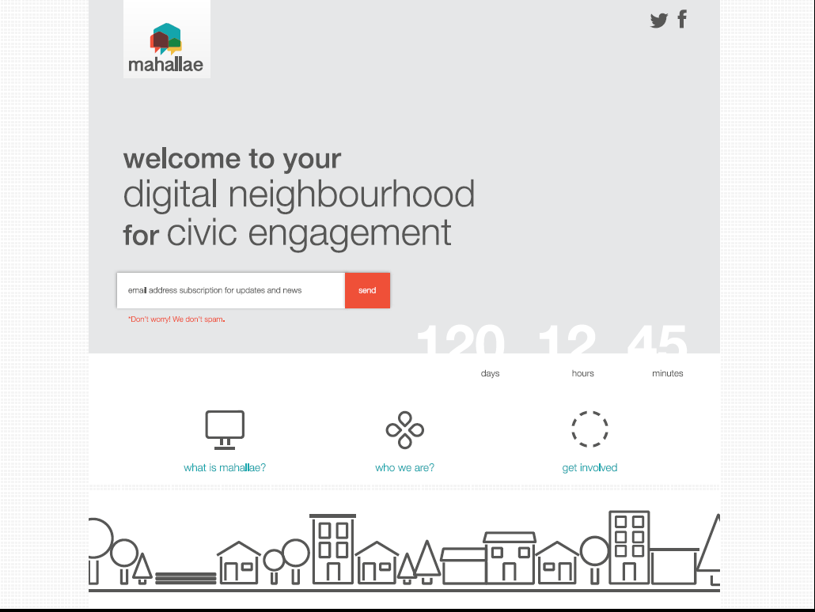

F. Gender mainstreaming in the peace process and wider reconciliation efforts

The work of UNDP in Cyprus is linked to the organisations 8 point agenda, specifically sections 3, 4, and 8, and to the Gender Equality Strategy for 2008-11 developed by the UNDP Regional Bureau for Europe and the CIS (RBEC). In 2009 a gender consultant was engaged by the Good Offices and UNDP-ACT, in close consultation with local stakeholders, to assess the progress of UNSCR 1325 in Cyprus and encourage more consistent reflections on gender-sensitive perspectives in the peace process and other reconciliation efforts. The consultant found that ten years after the adoption of UNSCR 1325 Cypriot women are still not at the negotiating table and their presence in all other institutions remained low. The missions also noted that concerns women’s were not well-integrated into the peace process or wider reconciliation efforts.

The assessment process led to the formation of a Gender Advisory Team (GAT). The GAT was formed by local women activists who came together to address the lack of inclusion of gender issues in the peace process and wider peacebuilding efforts. With the support of UNDP-ACT and the UN Good Offices, the GAT was able to engage with the UN and the gender focal points of the two leaders on integrating gender into the peace process, and even developed a series of recommendations on incorporating gender concerns into the governance chapter that were well received by the leaders.

UNDP has diligently monitored disaggregated data in order to measure the gender dimensions of projects conducted by its partners. Of the 61 activities tracked, the percentage of women and men participating is 35% and 65%, respectively, a bit short of gender parity levels. UNDP also developed a template of four questions on whether projects include a gender perspective, while all partners are required to collect gender disaggregated data and their agreement to do so is a prerequisite of the continued partnership. UNDP has also provided training and worked closely with its partners to include a more focused gender perspective in their programming.

Looking towards the period 2013-2015 UNDP Cyprus (CCE) will continue to support gender issues through its civic engagement strategy. The clearest expression of this work is reflected in the selection of high level women among the participants in the emerging track 2 process described under the participatory peacemaking initiative. In addition UNDP will focus on the following directions:
- Continued support to integrating gender perspectives into the Peace Process: UNDP will continue to support the development of the capacity for women’s leadership and participation in the peace process and seek to mainstream gender into the negotiations and a possible peace agreement. UNDP will continue to provide support to gender mainstreaming, both through the Gender Advisory Team and through other channels currently being identified jointly with its partners.
- Wider gender mainstreaming efforts: UNDP will continue to develop the national capacity of civil society partners to mainstream gender in their work. This will include strengthening mechanisms to collect and analyze data on women’s participation and on how gender concerns are integrated in its partners’ work
- Sharing knowledge and experience inter-regionally: Under specific portfolios UNDP will find ways of exchanging knowledge and development innovations between Cypriot and non-Cypriot civil society partners. For example this could be done through the Mahallae platform and the launching of gender-equity innovation grants which encourage inter-regional partnerships.

Results and Resources Framework
Intended Outcome as stated in the Country Programme Results and Resource Framework:
Cypriot inter-communal civil society sector positioned as a role model for engendering positive outcomes during socio-political transitions in Cyprus and its neighbourhood.
Outcome indicators as stated in the Country Programme Results and Resources Framework, including baseline and targets:

Indicator 1: Percentage of Cypriots that believe civil society has a positive impact on public policy

Baseline 2013 | Target 2014 | Target 2015
Greek Cypriot 27% | Greek Cypriot 35% | Greek Cypriot 45%
Turkish Cypriot 33% | Turkish Cypriot 35% | Turkish Cypriot 45%

Indicator 2: Volume of non USAID Cyprus funds mobilised to support inter-regional partnerships involving Cypriot civic organisations
Baseline 2013 | Target 2014 | Target 2015
60,000 USD | 200,000 USD | 350,000 USD

 | Applicable Key Result Area:
Partnership Strategy
The entire programme is predicated on innovative and cross-regional partnerships. UNDP and USAID collaboration in Cyprus has shifted to supporting a multi-donor approach to programming. Indeed the nature of the programme has already solicited the interest of donors and international NGOs which have already demonstrated a shared interest in the programme vision and willingness to consider partnering on components that fit within their specific mandates. To date the European Commission in Cyprus (on Southern Neighbourhood issues), the USAID Programme for Middle East Programmes (in support of Arab NGOs), the USAID office in Cyprus (in support of Cypriot NGOs) and selected UNDP Country Offices (e.g. Egypt, Kosovo, PAPP) have demonstrated an interest in the programme concept. From the perspective of the Cypriot CSOs, the programme would serve to create the conditions for developing capacities to partner with NGOs in the region which would help with their sustainability. For Cyprus the programme will help to position the island as a proactive supporter of development cooperation and assistance policy. This would help to attract a new kind of conference tourism, involving local and international cross-sectoral partnerships with positive effects on the island’s hospitality sector and local economy.

 | INTENDED OUTPUTS | OUTPUT TARGETS FOR (2013-2015) | INDICATIVE ACTIVITIES | RESPONSIBLE PARTIES | INPUTS US$
Output 1  Civic and political leaders engaged in a genuine track 2 process in Cyprus.  Baseline:  Less than 20% of the general public feel that their voices are being heard by the two Leaders  Indicators  20% increase in public confidence that the political elite are considering their concerns in the peace negotiations. |  | Targets year 1  - The two Leaders make a public commitment to involving civic leaders in consultation bodies which are designed to channel the concerns of the general public.  - Senior members of at least four political parties in each community jointly support a more inclusive and participatory design for the peace negotiations.  Targets Year 2  - Mechanisms for a track 2 process operating in both communities.  - New NGO Law passed in the Republic of Cyprus. | Activity 1: High level dialogue held involving Cypriot political party representatives and civic leaders , and chief peace negotiators from Northern Ireland South Africa and the Balkans  Action 1.1  Common action for a track 2 process presented to the two negotiators by a bi-communal group of influential civic leaders.  Action .1.2  Mono-communal and bi-communal track 2 forums created.  Action 1.3  Public outreach tools, such as polls and town hall meetings designed and rolled out to solicit public opinion on the process. | ENGI | Action 1.1  USD 200,000  Action 1.2  USD 100,000  Action 1.3  USD 150,000
 |  |  | Activity 2: Greek Cypriot NGOs successfully influence the content of the new NGO Law in the Republic of Cyprus  Action 2.1  Regular consultations take place between NGOs and the Presidential commissioner for civil society.  Action 2.2  European examples of NGO legislation discussed with government and NGOs.  Action 2.3  Changes to draft NGO law made through public consultations | UNDP | Action 2.1  USD 169,677  Action 2.2  USD 150,000  Action 2.3  USD 180,000
Sub-total Output 1
USD 949,677

Output 2: Cypriot experiences in civic engagement leveraged to support and sustain inter-regional partnerships for social cohesion.  Baseline:  Five inter-regional grants funded in 2013  Indicators:  Two organizations in the European Neighbourhood region utilise Cypriot experience to support social policy. |  | Targets year 1  - Five inter-regional projects designed and implemented.  - One partnership with one non-Cypriot organization established with co-funding secured from non-Cypriot sources.  Targets year 2  - Five inter-regional projects designed and implemented.  - Two partnerships with two non-Cypriot organizations established with co-funding secured from non-Cypriot sources.  - Cyprus Aid and Cypriot NGOs host 1 high level inter-donor and civil society consultation on the post-2015 development agenda | Activity 1: Youth Leaders Support programme trains 50 youth leaders from Cyprus and at least 2 Arab countries  Action 1.1  Projects solicited and assessed through competitive process and Cypriot lead organisations contracted  Action 1.2  Programme designed and civil society youth leaders trained in various aspects of civil society development  Action 1.3  Inter-regional youth and gender projects designed and multi-donor resources secured to support their implementation.  Action 1.4  Two inter-regional partnerships formed under the 2012 Power of One Inter-regional Knowledge Exchange Conference scaled up. | Selected NGOs  CCMC and Youth Power (see Management Arrangements for details) | Action 1.1  USD 200,000  Action 1.2  USD 50,000  Action 1.3  USD 127,000  Action 1.4  USD 300,000
 |  |  | Activity 2: Cyprus Aid and Cypriot CSOs from both communities convene a post-2015 development agenda Forum for the Eastern Mediterranean  Action 2.1  Agenda and logistics for Forum agreed with Cyprus Aid and key resource persons identified.  Action 2.2  Financing mechanism agreed and Forum Steering Committee established.  Action 2.3  Cyprus Aid issues invitations to governments, civil society, donors to attend forum.  Action 2.4  At least 3 inter-regional partnerships identified through forum and funded to support the post-2015 development agenda in the Eastern Mediterranean. | UNDP | Action 2.1  USD 50,000  Action 2.2  USD 20,000  Action 2.3  USD 80,000  Action 2.4  USD 200,000
 |  |  | Activity 3: Cypriot successes in CSO advocacy leading to changes legislation and practices shared with a wider inter-regional network CSO practitioners  Action 3.1  Technical support provided to Cypriot NGOs advocating for the adoption of community media legislation in Cyprus.  Action 3.2  Technical support provided to Cypriot NGOs attempting to introduce multi-perspective history teaching materials into Greek Cypriot and Turkish Cypriot schools.  Action 3.3  Interactive knowledge products and specialised symposiums outlining the lessons learned created and shared with Arab and  European advocates of community media and multi-perspective history teaching. | Selected NGOs | Action 3.1  USD 50,000  Action 3.2  USD 100,000  Action 3.3  USD 150,000
Sub-total Output 2
USD 1,327,000

 | Output 3: Innovation and knowledge exchange applied to evidence-based policy making in the European Neighbourhood  Baseline:  Mahallae digital platform and SCORE Index created in Cyprus  Indicators:  - Two inter-regional communities of practice hosted and functioning through the Mahallae platform  - SCORE index utilized in Cyprus and replicated in 2 countries of the European Neighbourhood | Targets year 1  - Five innovation grants funded  - Interest in the SCORE expressed by organizations from at least 5 countries.  Targets year 2  - Five innovation grants funded  - Co-funding secured for inter-regional innovation partnerships  - SCORE adopted as a tool by UNDP RBEC to support conflict and post conflict programming. | Activity 1: Mahallae digital platform established as the centre of gravity for peace innovation activities for civil society organisations working in countries of the Eastern Mediterranean  Action 1.1  Contractual services for Mahallae infrastructure development secured.  Action 1.2  Civic engagement innovation grants scheme launched  Action 1.3  Results of innovation grants disseminated through Mahallae platform | UNDP | Action 1.1  USD 80,000  Action 1.2  USD 111,000  Action 1.3  USD 50,000
 |  |  | Activity 2: SCORE interactive digital platform acknowledged as an instructive tool for peace and development professionals  Action 2.1  International workshop involving CSOs, donors and senior UNDP officials from RBEC/RBAS country offices and New York convened to launch the SCORE.  Action 2.2  SCORE replicated in Bosnia in cooperation with USAID  Action 2.3  Consultations on the SCORE index take place with UNDP country offices and governments which demonstrate a serious interest in replication.  Action 2.4  Partnership arrangements secured to replicate SCORE outside Cyprus.  Action 2.5  SCORE data updated and analysis conducted for Cyprus in support on the island’s peace process, and results shared with negotiation teams and UN Good Offices. | The Centre for Sustainable Peace and Democratic Development (SeeD) | Action 2.1  USD 70,000  Action 2.2  USD 70,000  Action 2.3  USD 20,000  Action 2.4  USD 30,000  Action 2.5  USD 6,000
Sub-total Output 3
USD 437,000

